Incident Lifecycle Automation in ServiceNow
1. Problem Statement
Organizations receive a large number of IT incidents such as VPN failures, application errors, hardware issues, password problems, and network connectivity failures. Managing these incidents manually can result in delayed assignment, inconsistent prioritization, missed SLAs, and poor communication between support teams.
The Incident Lifecycle Automation in ServiceNow project aims to automate the incident management process from creation to closure using ServiceNow features such as Incident Management, Assignment Rules, Business Rules, Notifications, SLAs, Workflows/Flow Designer, and Incident States.
The system will ensure that incidents are automatically categorized, prioritized, assigned to the appropriate support group, monitored against SLA targets, and properly closed.
2. Ideation Phase
2.1 Project Idea
The idea is to develop an automated incident management system in ServiceNow that manages the complete lifecycle of an incident.
Incident Lifecycle
Incident Creation → Categorization → Prioritization → Assignment → Investigation → Resolution → Closure
Automation will reduce manual intervention and help support teams resolve incidents faster.
2.2 Vision
To create a reliable and automated incident management process that improves:
- Incident response time
- Assignment accuracy
- SLA compliance
- Incident tracking
- Support-team productivity
- Customer satisfaction
2.3 Proposed Solution
The proposed ServiceNow solution will:
- Allow users to create incidents.
- Automatically determine incident category and priority based on predefined conditions.
- Automatically assign incidents to appropriate support groups.
- Notify relevant users and support teams.
- Track SLA deadlines.
- Escalate incidents when SLA thresholds are approaching or breached.
- Allow support teams to update incident progress.
- Ensure incidents follow a controlled lifecycle.
- Automatically close resolved incidents after the required conditions are satisfied.
3. Requirement Analysis
3.1 Business Objectives
The major business objectives are:
- Reduce manual incident processing.
- Improve incident assignment.
- Reduce incident resolution time.
- Improve SLA compliance.
- Provide visibility into incident status.
- Standardize the incident lifecycle.
- Improve communication between users and support teams.
- Provide accurate incident tracking and reporting.
3.2 Functional Scope
The system should support the following functions:
Incident Creation
Users should be able to create incidents by providing information such as:
- Caller
- Short Description
- Description
- Category
- Subcategory
- Impact
- Urgency
Automatic Prioritization
The system should calculate incident priority based on Impact + Urgency.
Example:
Impact | Urgency | Priority
High | High | Critical
High | Medium | High
Medium | Medium | Moderate
Low | Low | Low
Automatic Assignment
Incidents should be automatically assigned to appropriate support groups based on their category.
Example:
- Network → Network Support
- Software → Application Support
- Hardware → Hardware Support
- Database → Database Support
SLA Management
An SLA should be attached automatically based on incident priority.
The system should monitor:
- SLA start time
- SLA duration
- Time remaining
- SLA percentage
- SLA breach
Notifications
Notifications should be generated for important events such as:
- New incident created
- Incident assigned
- Incident reassigned
- Incident resolved
- SLA approaching breach
- SLA breached
- Incident closed
4. Stakeholder Mapping
Stakeholder | Responsibility
End User | Reports incidents
Service Desk Agent | Investigates and manages incidents
Support Group | Resolves technical issues
Incident Manager | Monitors incident process
System Administrator | Configures ServiceNow
Management | Reviews reports and performance

5. Non-Functional Requirements
The application should provide:
Performance
Incident creation and assignment should happen quickly.
Security
Only authorized users should be able to view or modify incidents.
Availability
The incident management system should be available to support teams during business operations.
Scalability
The system should support increasing numbers of incidents and users.
Auditability
Incident updates and changes should be traceable.
6. Project Design Phase
6.1 System Architecture
The project will use ServiceNow's standard Incident Management architecture.
User
↓
Incident Creation
↓
Incident Table
↓
Business Rules / Flow Designer
↓
Categorization & Prioritization
↓
Assignment Rules
↓
Support Group
↓
SLA Monitoring
↓
Resolution
↓
Closure
6.2 ServiceNow Components
The project will primarily use:
- Incident table
- Users
- Groups
- Assignment Rules
- Business Rules
- Client Scripts
- UI Policies
- Data Policies
- Flow Designer
- Notifications
- SLA Definitions
- Reports
- Dashboards
- Service Operations Workspace
6.3 Incident Lifecycle Design
The incident states will follow:
New
↓
In Progress
↓
On Hold (if required)
↓
Resolved
↓
Closed
Each state will have specific conditions.
New
Incident has been created but not yet investigated.
In Progress
Support team is actively working on the incident.
On Hold
Work is temporarily paused because additional information or an external dependency is required.
Resolved
The technical issue has been fixed.
Closed
The incident has completed the closure process.

7. Project Planning Phase
7.1 Project Milestones
Milestone 1 — Incident Creation
Steps:
- Configure Incident table.
- Create a test user.
- Create a new incident.
- Configure mandatory fields.
- Verify incident creation.
Milestone 2 — Incident Assignment
Steps:
- Identify incident categories.
- Create support groups.
- Configure assignment rules.
- Map categories to support groups.
- Test automatic assignment.
Example:
Category = Network
→ Assignment Group = Network Support
Milestone 3 — Priority Automation
Steps:
- Configure Impact.
- Configure Urgency.
- Configure Priority.
- Define priority conditions.
- Test different combinations.
Milestone 4 — SLA Automation
Steps:
- Create SLA definitions.
- Define SLA conditions.
- Associate SLA with incident priority.
- Configure response/resolution targets.
- Test SLA timers.
- Configure escalation.
Milestone 5 — Notifications
Steps:
- Create notification for incident creation.
- Create assignment notification.
- Create resolution notification.
- Configure SLA notifications.
- Test email/ServiceNow notifications.
Milestone 6 — Incident Resolution and Closure
Steps:
- Assign incident to support agent.
- Investigate issue.
- Add work notes.
- Update resolution information.
- Change state to Resolved.
- Verify closure conditions.
- Close the incident.
8. Project Development Phase
8.1 Incident Configuration
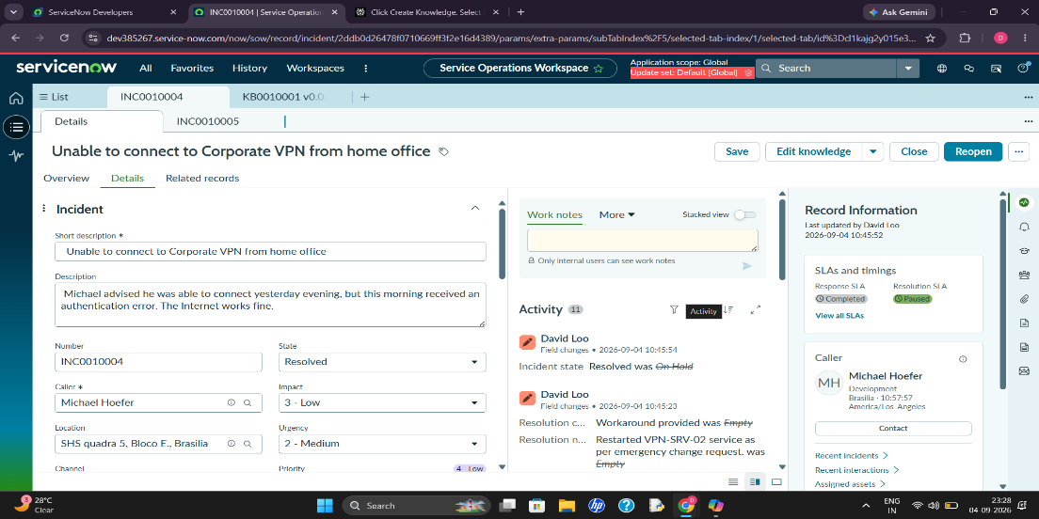

- Number
- Caller
- Short Description
- Description
- Category
- Subcategory
- Impact
- Urgency
- Priority
- State
- Assignment Group
- Assigned To
- Work Notes
- Additional Comments
- Resolution Notes
8.2 Assignment Automation
Create Assignment Rules that automatically select the appropriate group.
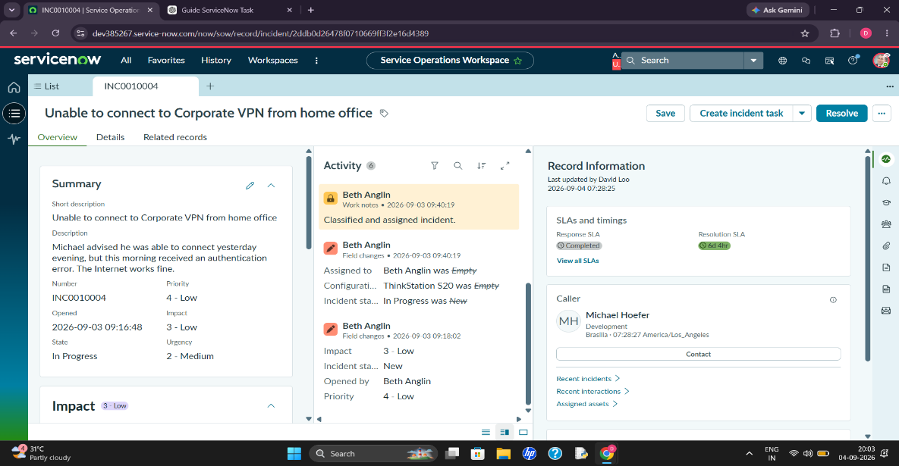
Example:
IF Category = Network
THEN Assignment Group = Network Support
IF Category = Software
THEN Assignment Group = Application Support
IF Category = Hardware
THEN Assignment Group = Hardware Support
8.3 Priority Automation
Configure the system to determine priority from impact and urgency.
Example:
Impact = High
Urgency = High
↓
Priority = Critical
This ensures that important incidents receive immediate attention.
8.4 SLA Configuration
Create SLA definitions for different incident priorities.
Example:
Priority | Resolution Target
Critical | 4 Hours
High | 8 Hours
Moderate | 2 Business Days
Low | 5 Business Days
The exact targets can be modified according to the organization's SLA policy.
8.5 Business Rules / Flow Designer
Automation can be implemented using Business Rules or Flow Designer.
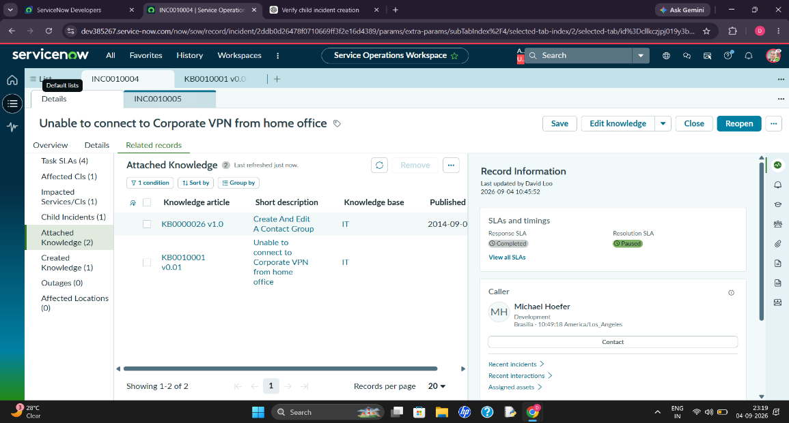
Example flow:
Incident Created
↓
Check Category
↓
Determine Assignment Group
↓
Determine Priority
↓
Attach SLA
↓
Notify Support Group
↓
Monitor Incident
↓
SLA Warning
↓
Escalation if Required

9. Testing Phase
The project should be tested using different incident scenarios.
Test Case | Expected Result
Create Network incident | Assigned to Network Support
Create Hardware incident | Assigned to Hardware Support
High impact + High urgency | Critical priority
Create incident | SLA automatically attached
Assign incident | Assigned user receives notification
Resolve incident | Resolution information required
Close incident | Incident successfully closed
SLA approaching breach | Notification/escalation triggered

10. Expected Outcome
After implementation, the organization should have:
- Automated incident assignment
- Automated prioritization
- SLA monitoring
- Automated notifications
- Standardized incident lifecycle
- Faster incident resolution
- Better support-team productivity
- Improved incident visibility
- Reduced manual errors
11. Project Execution Roadmap
You can put this near the top of your Google Doc, matching the structure in your screenshot:
Incident Management Automation in ServiceNow

Problem Statement

Objective

Phase 1: Ideation

1. Project Idea
2. Vision
3. Proposed Solution

Phase 2: Requirement Analysis

1. Business Objectives
2. Functional Scope
3. Stakeholder Mapping
4. Non-Functional Requirements

Phase 3: Project Design

1. System Architecture
2. ServiceNow Components
3. Incident Lifecycle Design
4. Automation Design

Phase 4: Project Planning

Milestone 1: Incident Creation
Milestone 2: Incident Assignment
Milestone 3: Priority Automation
Milestone 4: SLA Automation
Milestone 5: Notifications
Milestone 6: Resolution & Closure

Phase 5: Project Development

1. Incident Configuration
2. Assignment Automation
3. Priority Automation
4. SLA Configuration
5. Notifications
6. Business Rules / Flow Designer
7. Testing
8. Deployment

